Year 12 Chemistry Examination Solutions Semester 1 2001

Multiple Choice
1A 2A 3B 4C 5A 6B 7D 8C 9A 10C 11B 12C 13A 14B 15A 16D 17D 18B 19C 20B 21D 22A 23A 24B 25D 26B 27B 28C

Short Answer

Question 1
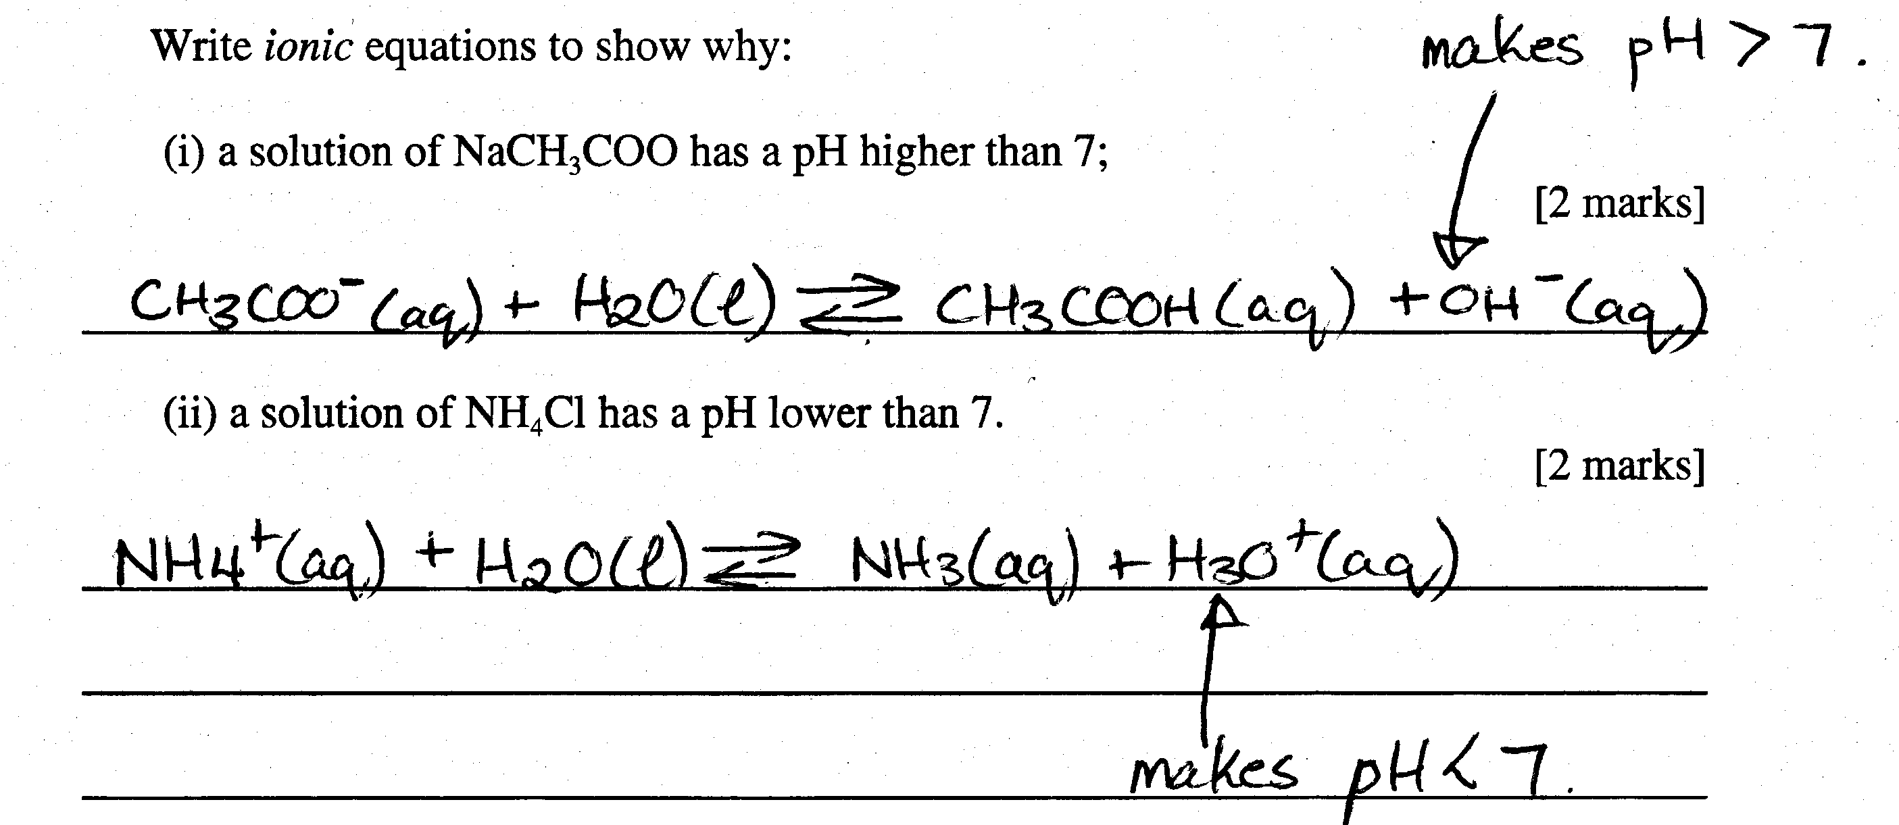
Question 2
(i)
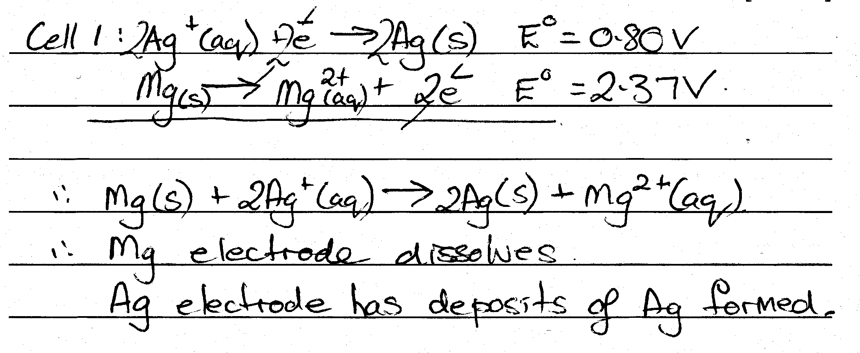
(ii)
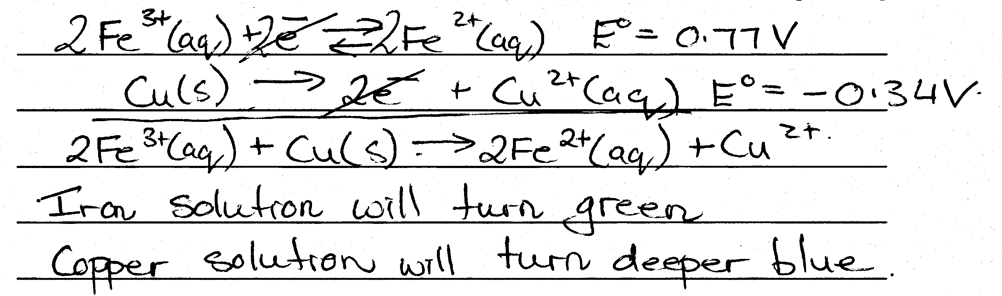
(iii)
Eº_{cell} = 0.80 + 2.37 = 3.17 V
(iv)
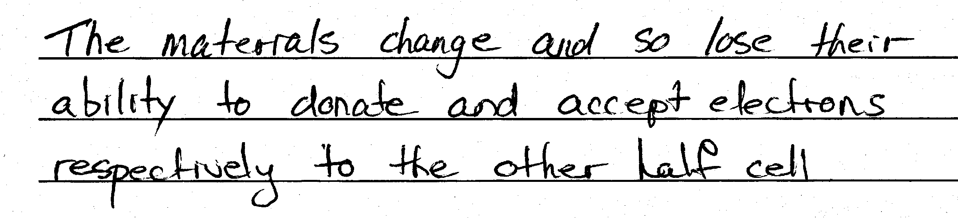
(v)
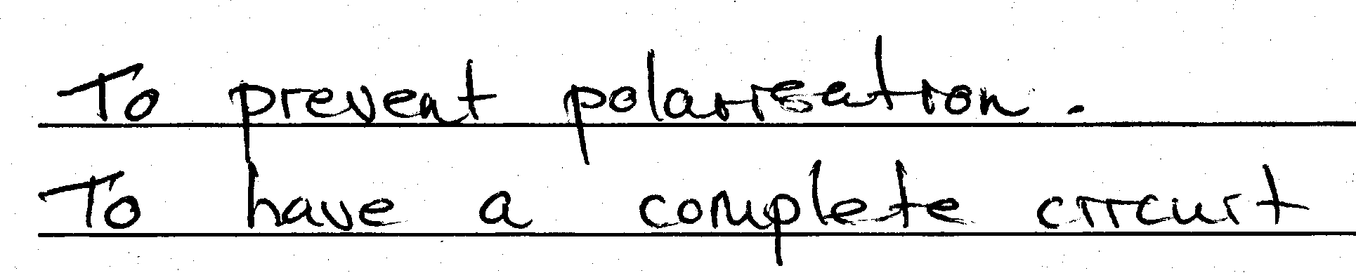
(vi)
Fe³⁺ is the oxidising agent. Oxidation occurs at the Cu electrode which is the anode.
Question 3
(i) +5
(ii) C in (COOH)₂
(iii) (COOH)₂ (aq) ----> 2CO₂ (g) + 2H⁺ (aq) + 2e
(iv) 6e + 6H⁺ (aq) + BrO₃⁻ (aq) ----> Br⁻ (aq) + 3H₂O(l)
(v)
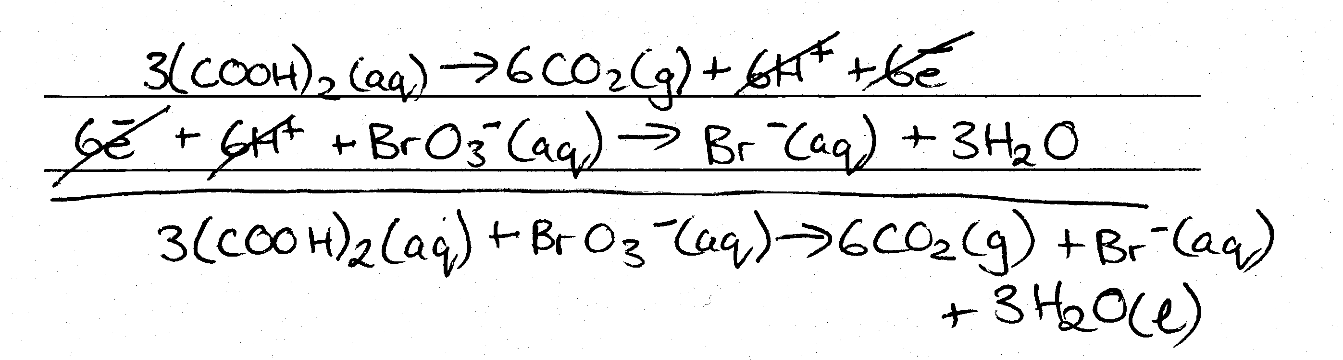
Question 4
(i)
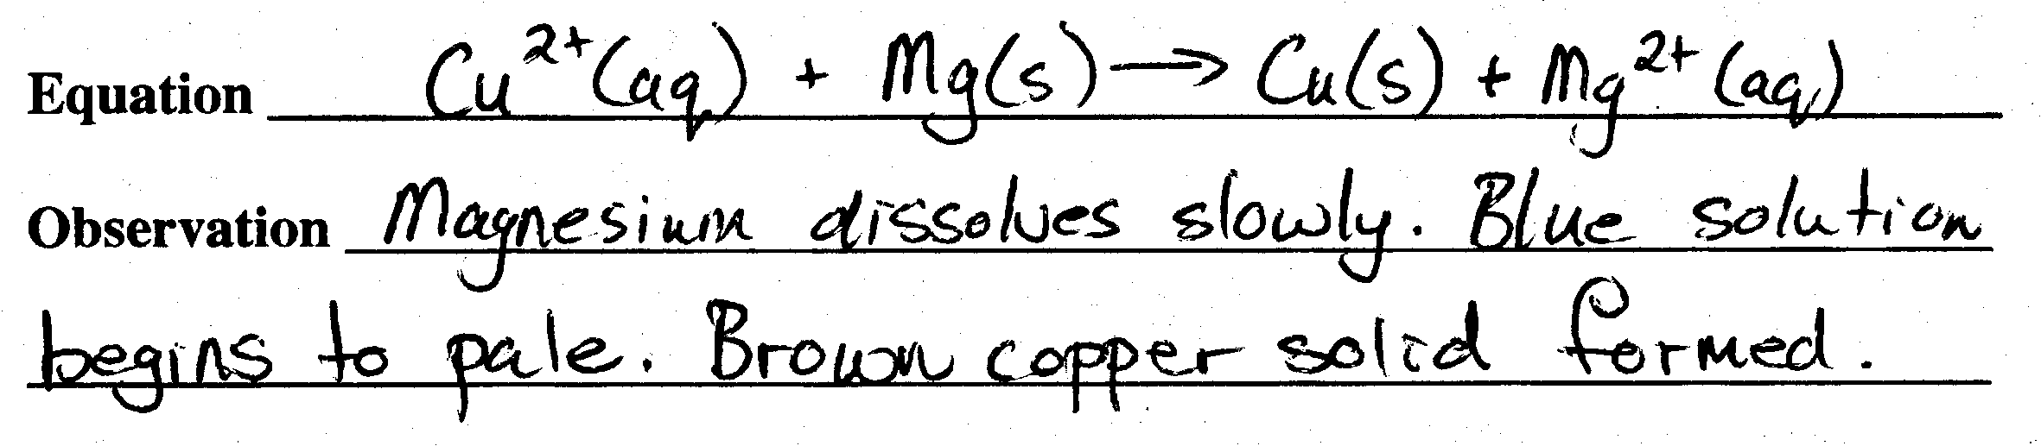

(ii)
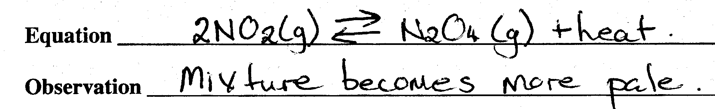
(iii)
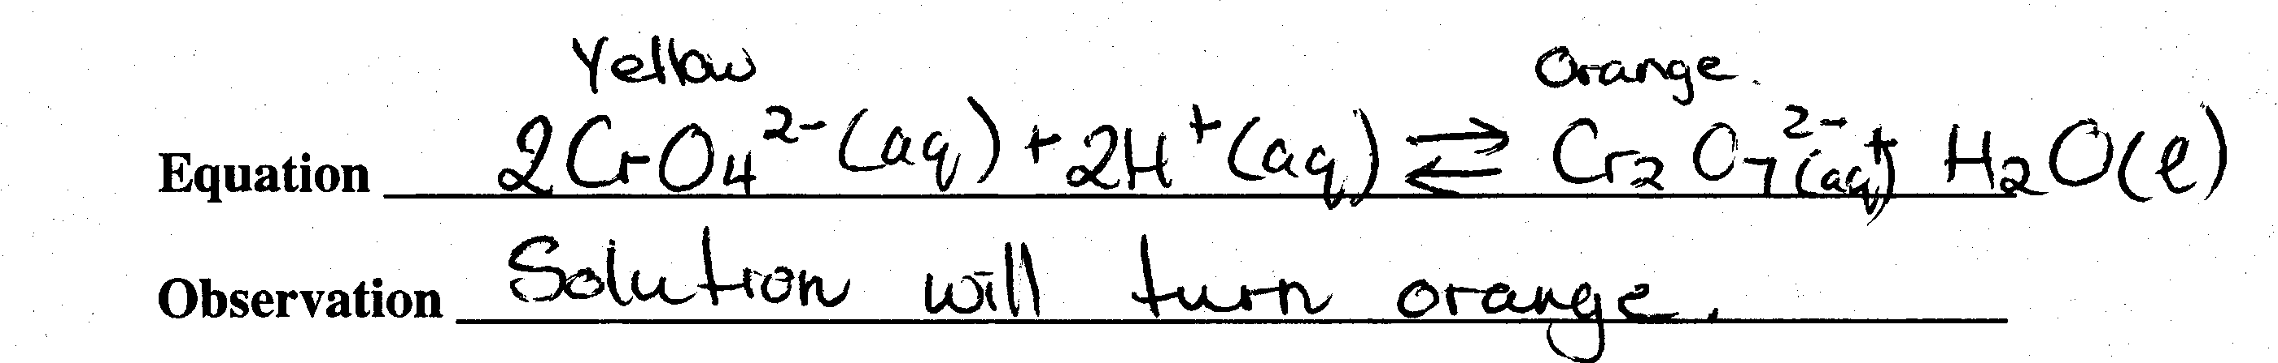
(iv)
Equation: 2HCl(aq) + Na₂S(aq) ---> 2NaCl (aq) + H₂S (g)
Observation: putrid smell, bubbles
(v)
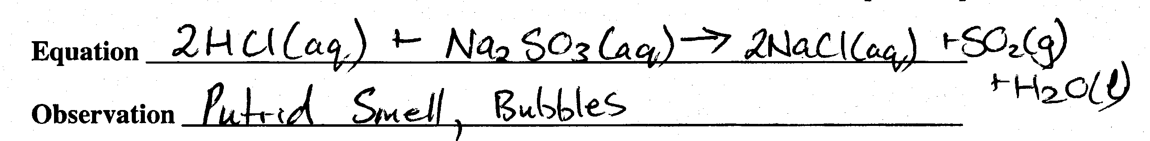
Question 5
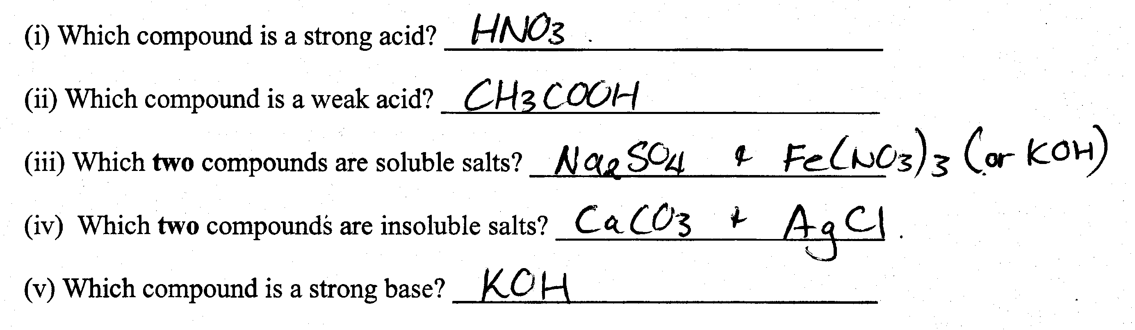
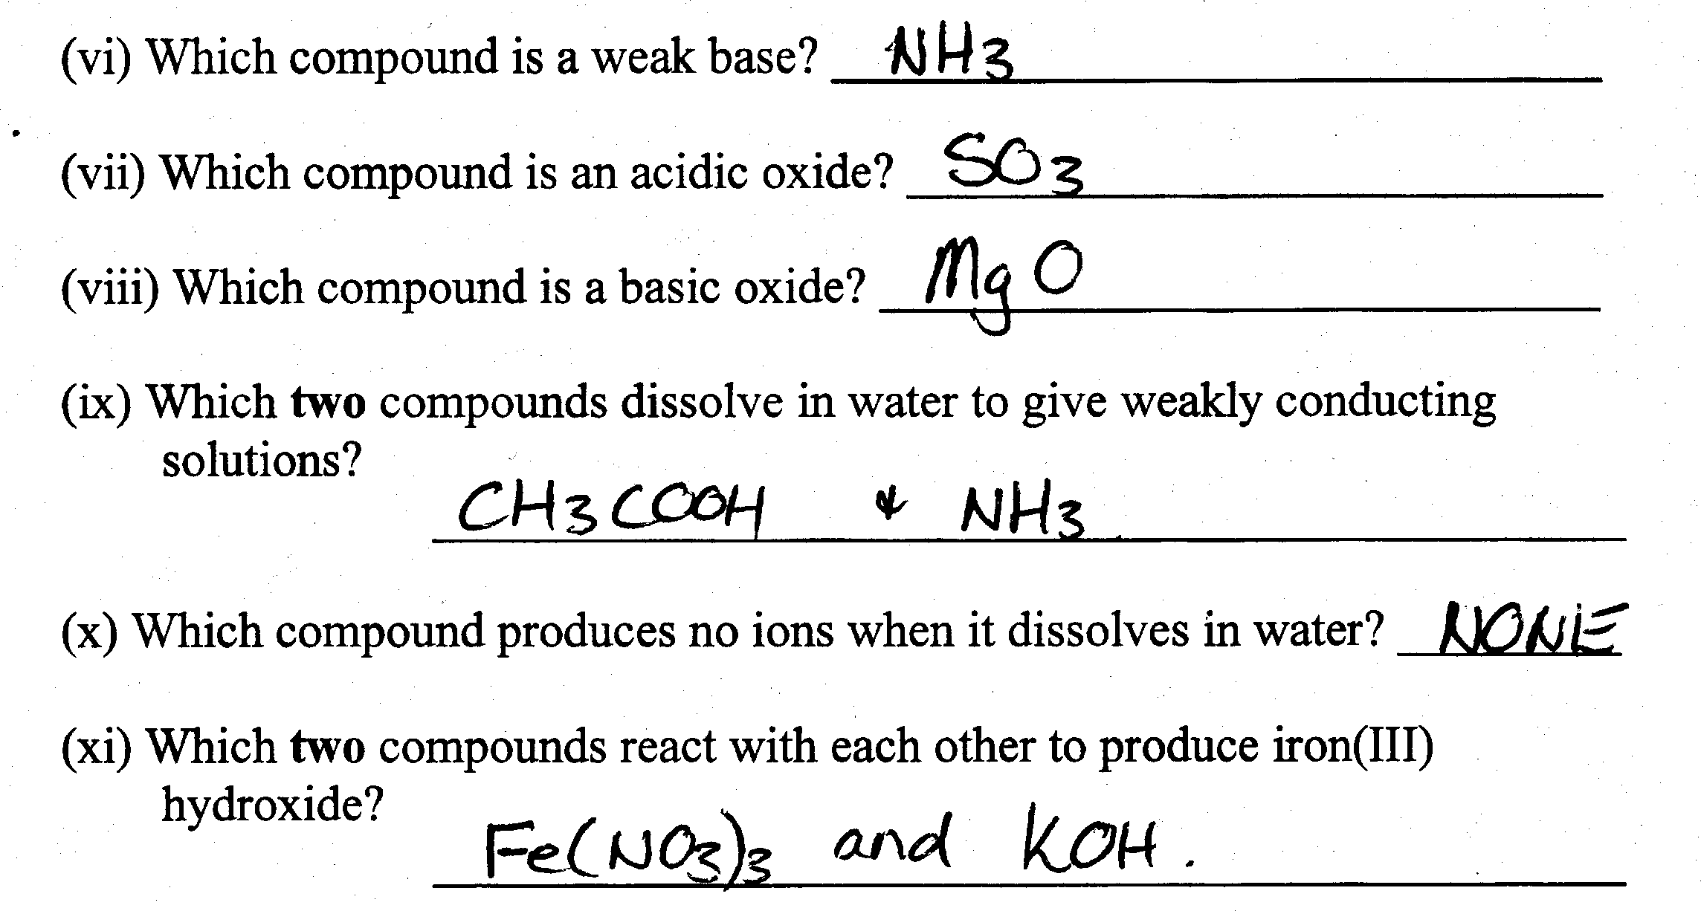
Question 6
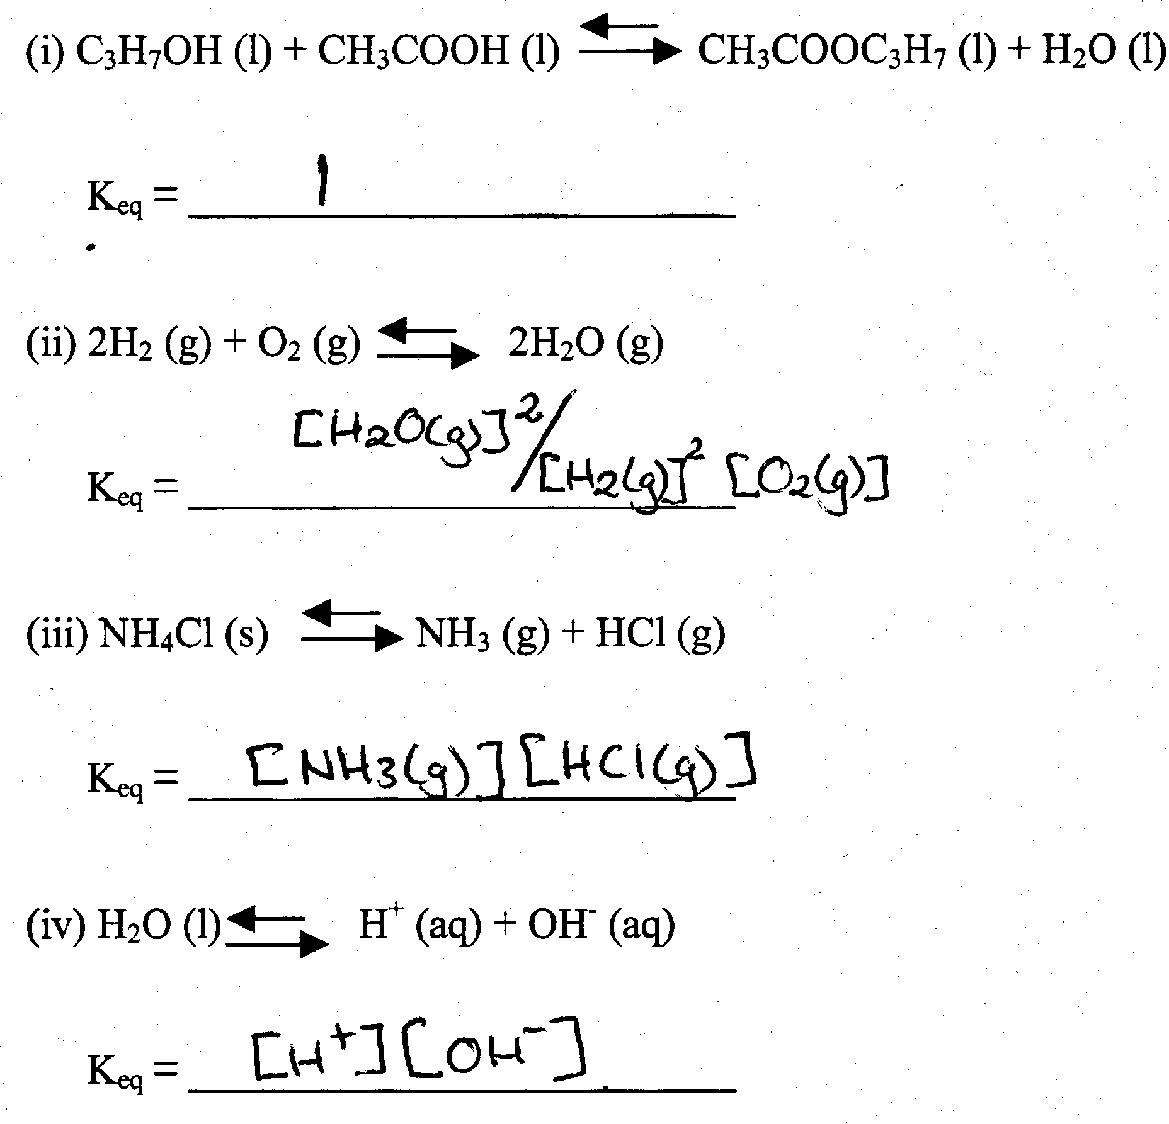
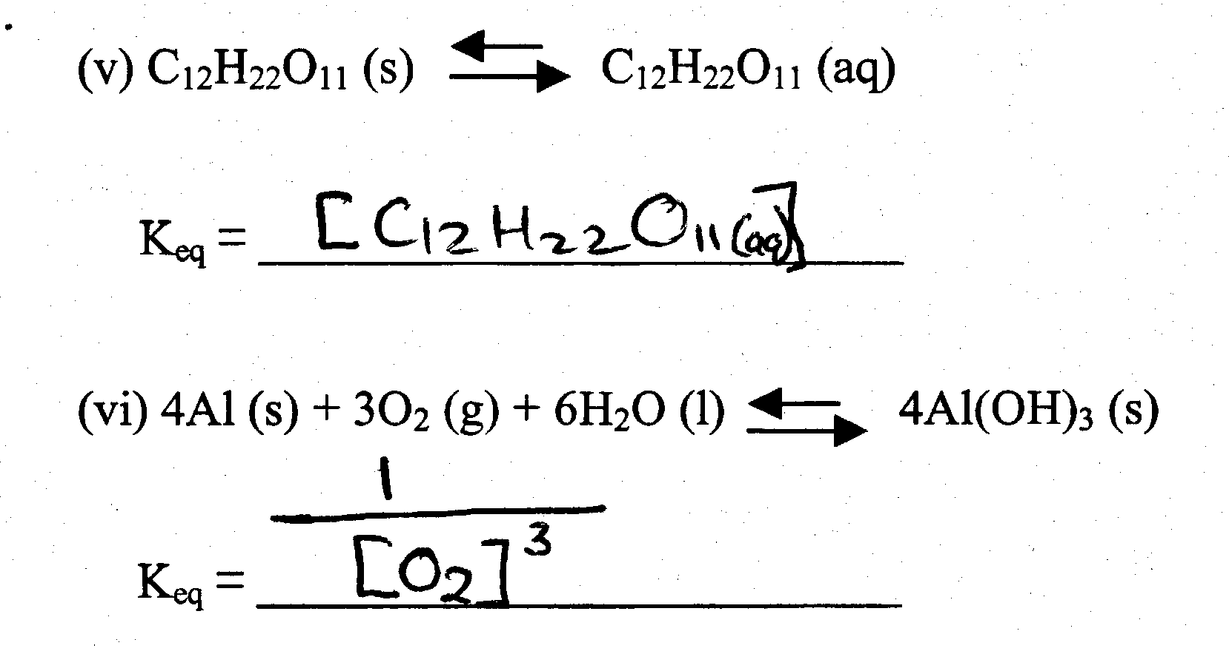
Question 7
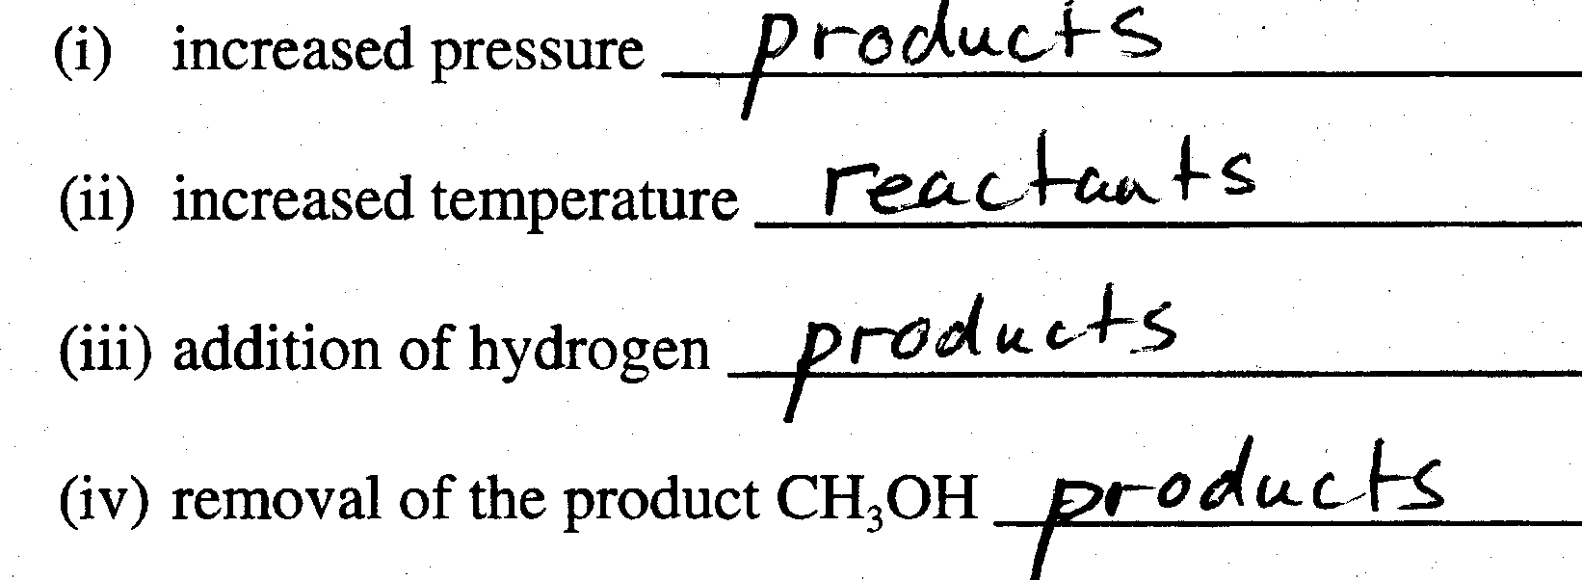
Question 8
(i)
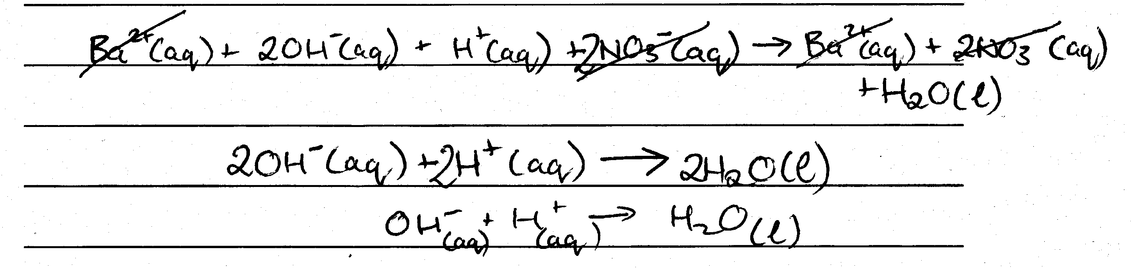
(ii)
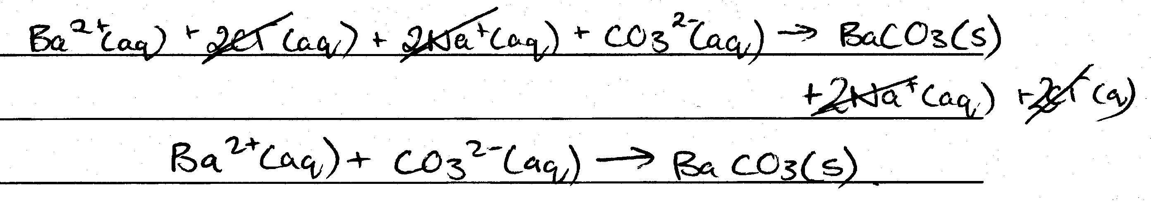
(iii)
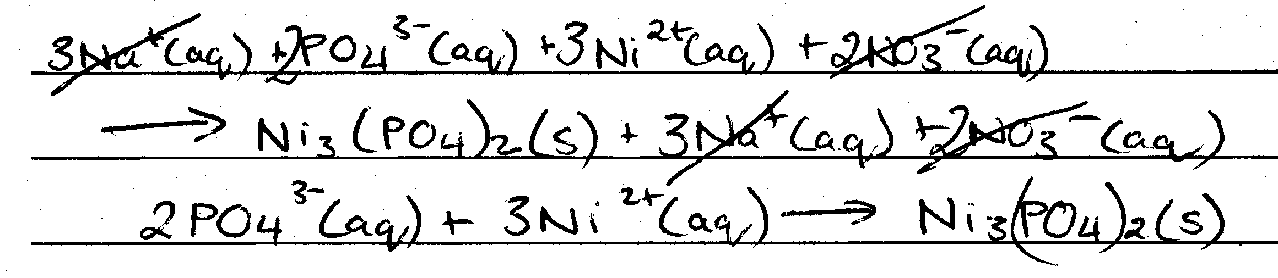
(iv)
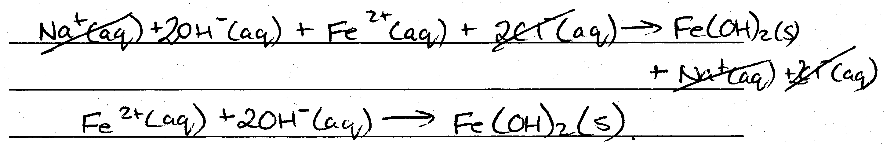

Calculations
Question 1
(i)
(ii)
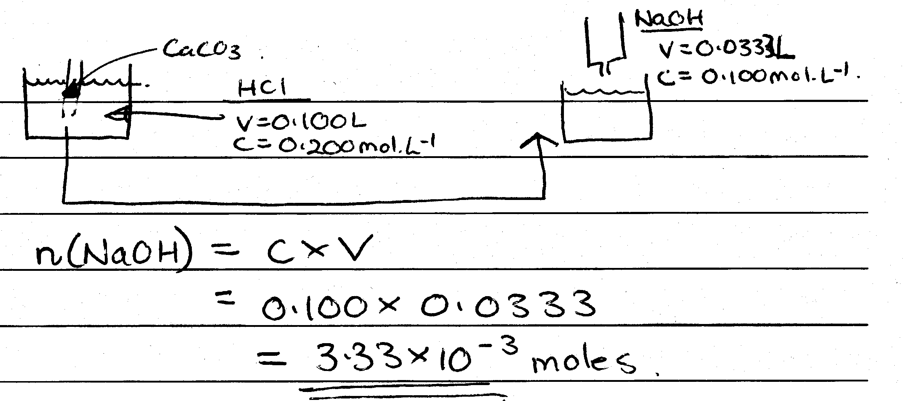
(iii)
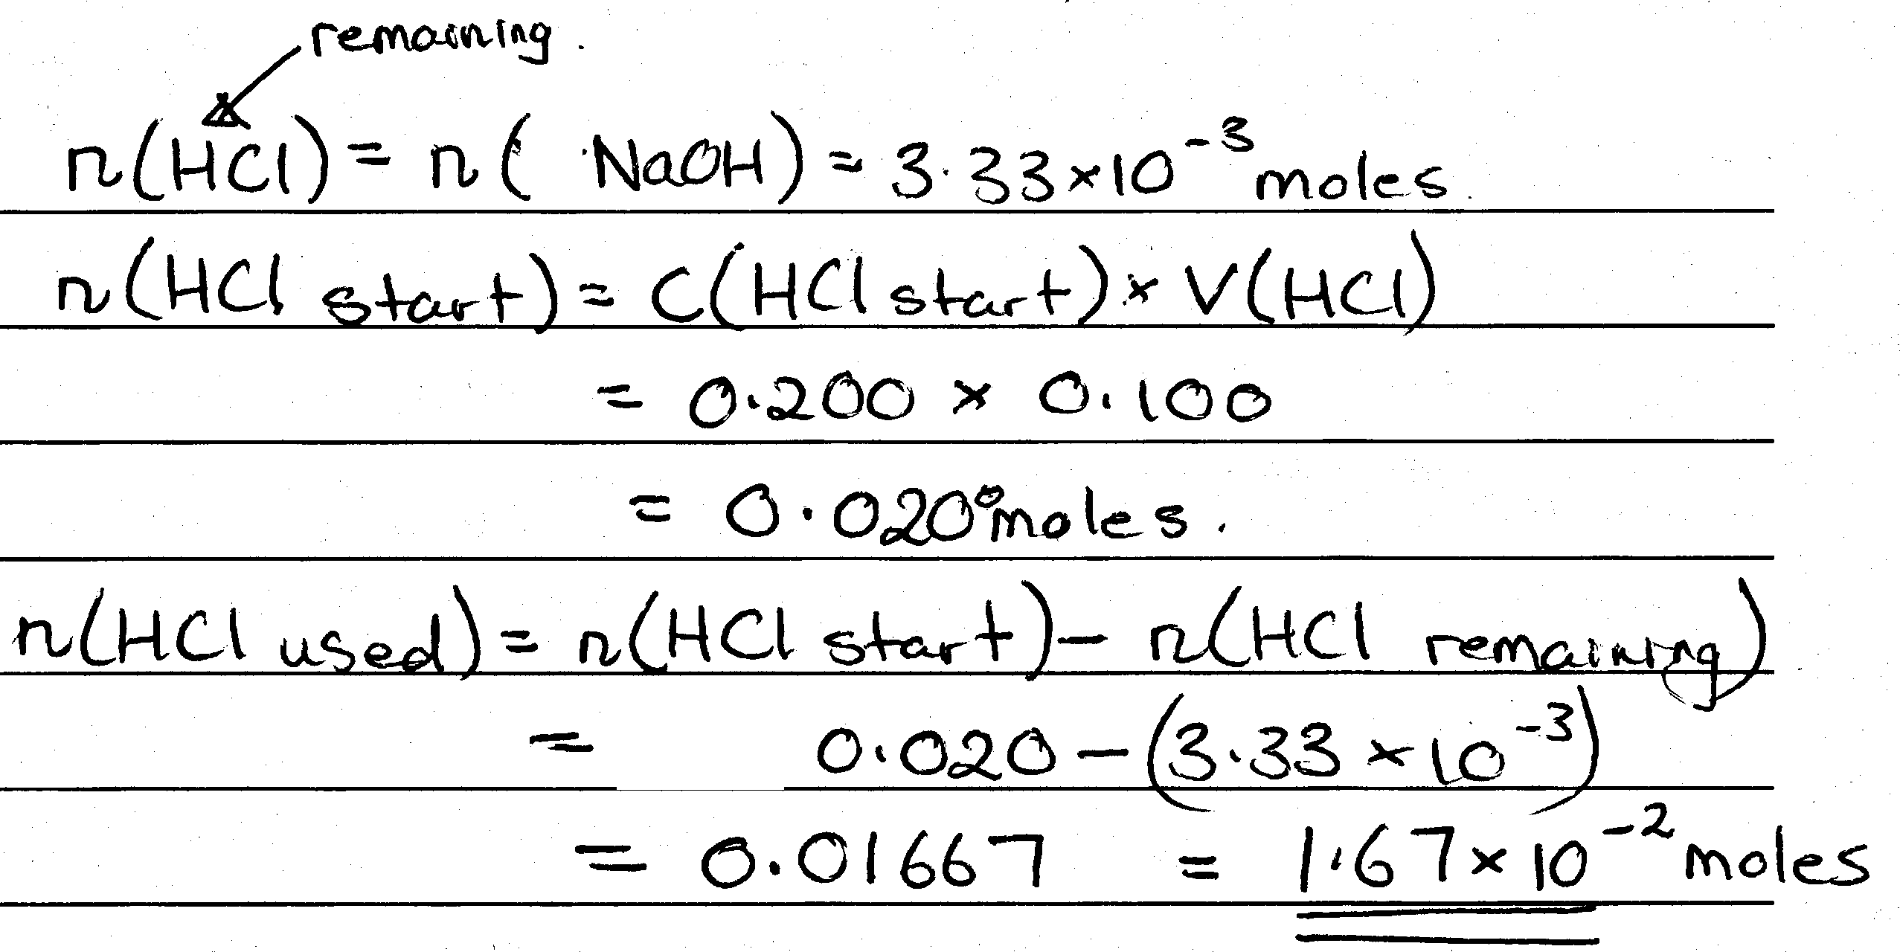
(iv)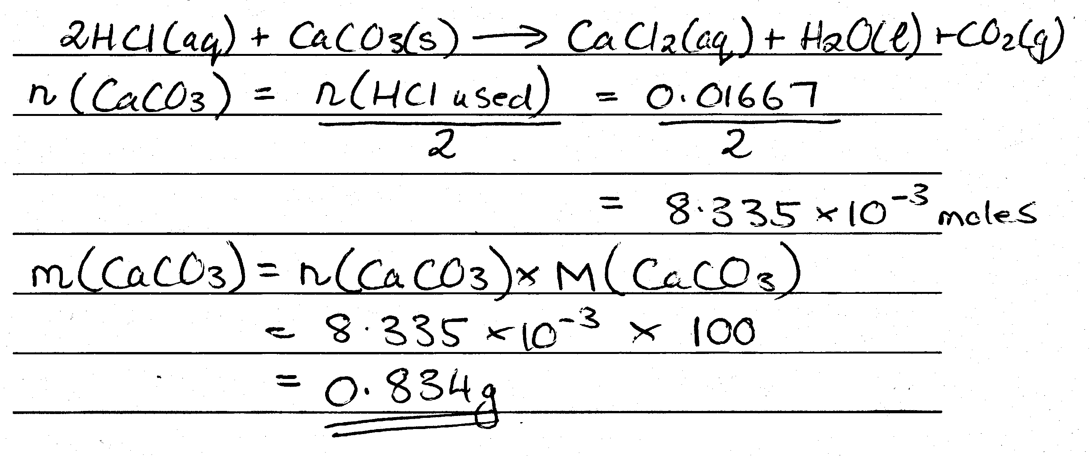
Question 2
(i)
(ii)
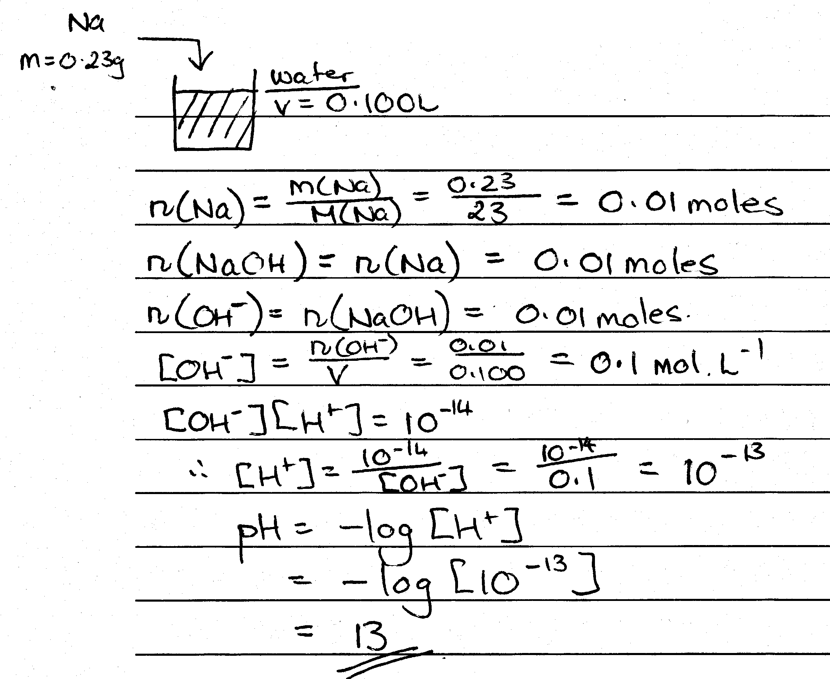
Question 3
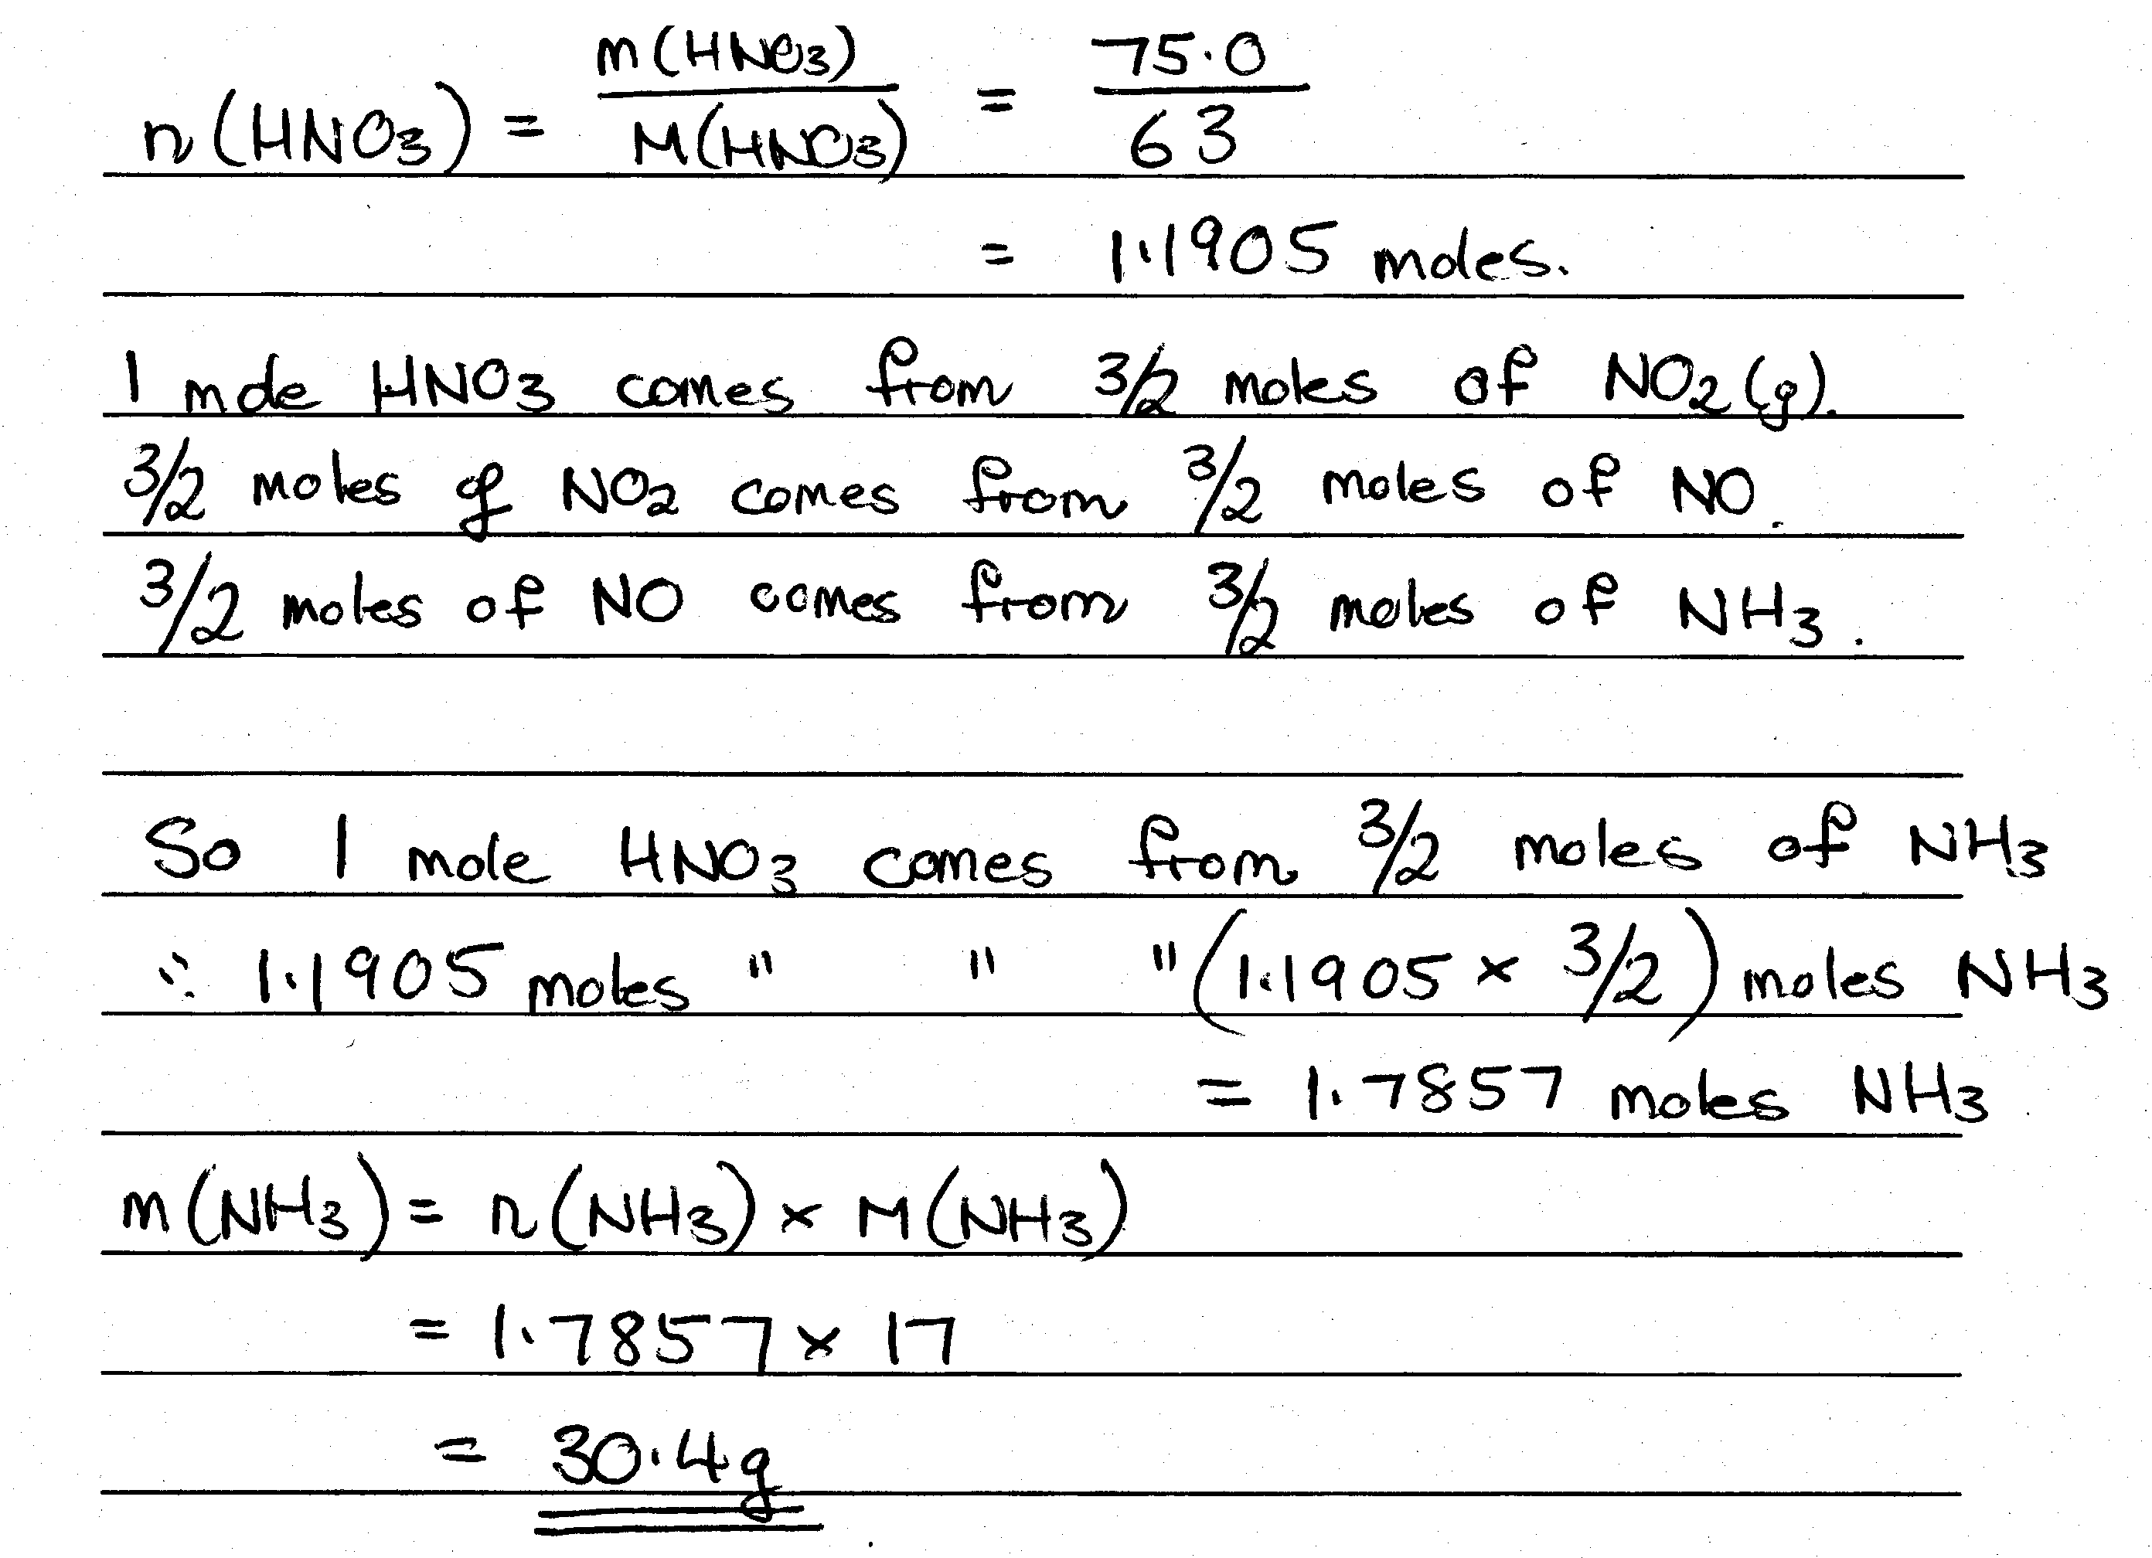
Question 4
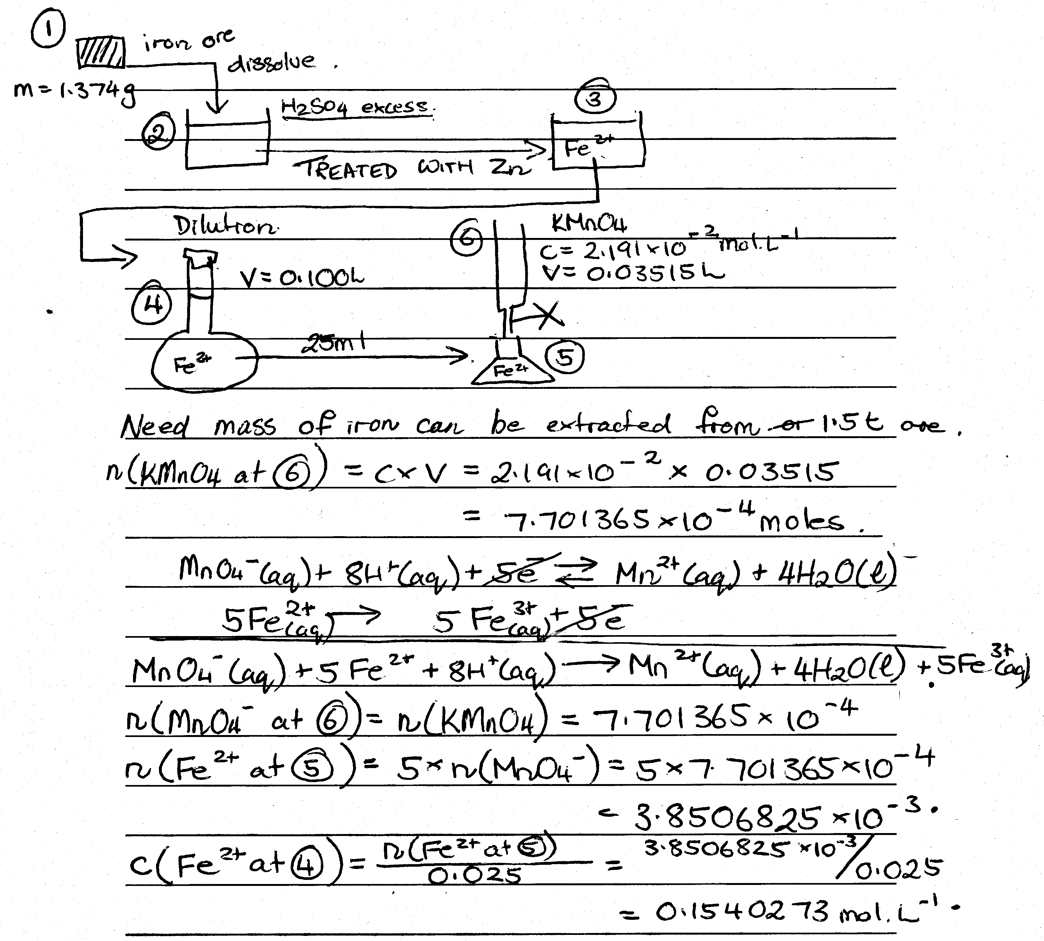
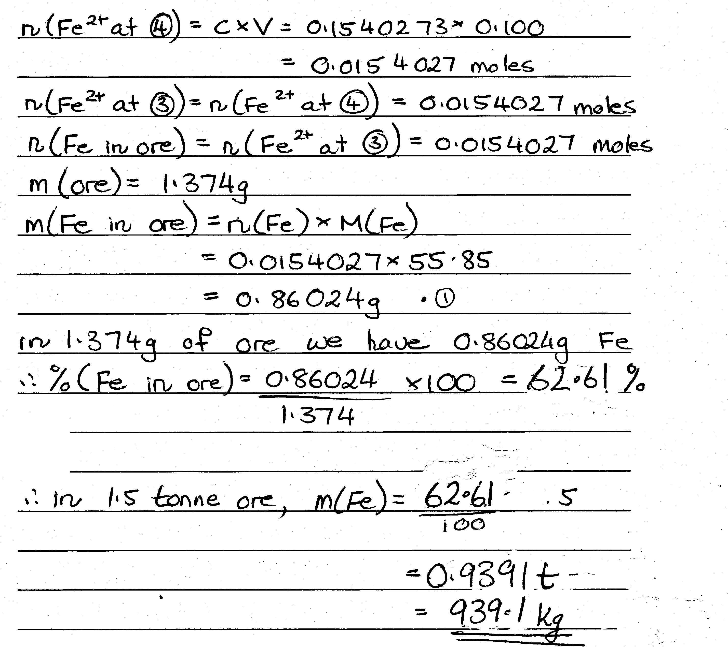
Question 5
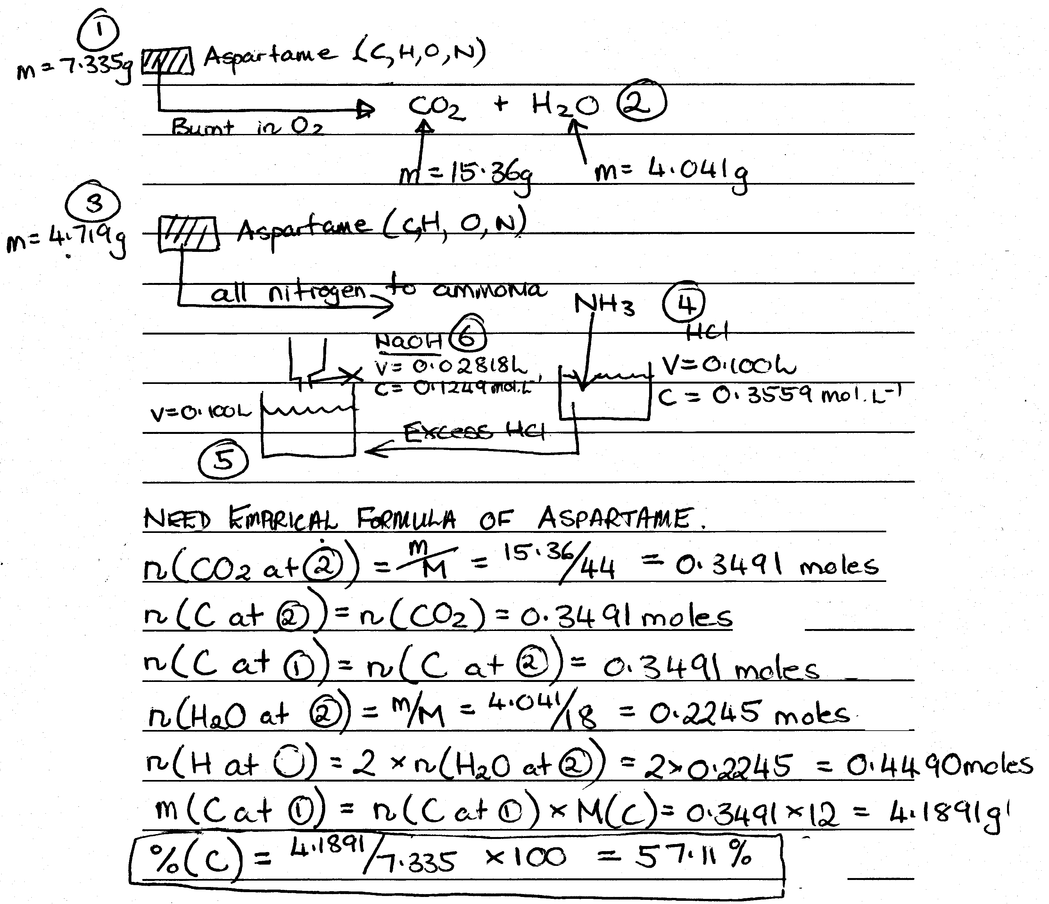
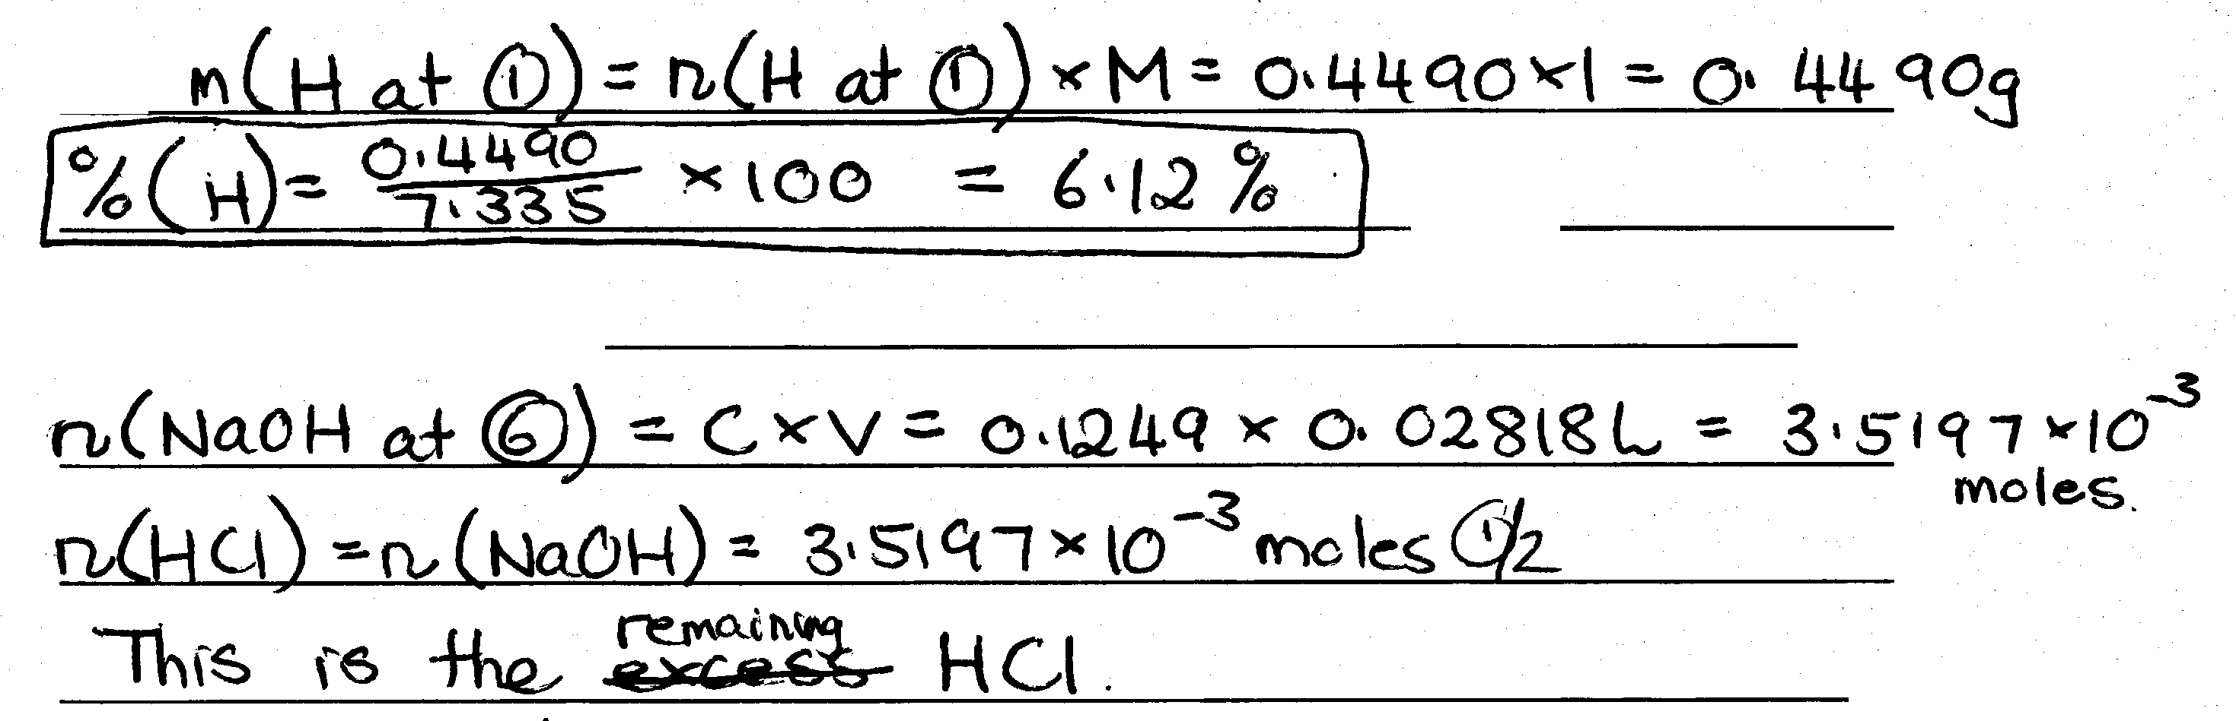
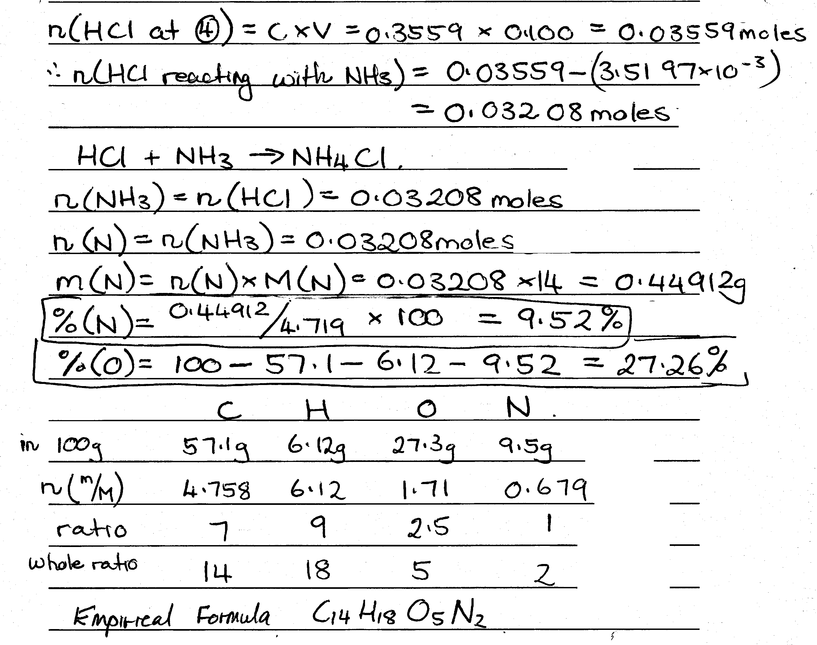
Essay
Question 1
(R. Perry’s Essay)
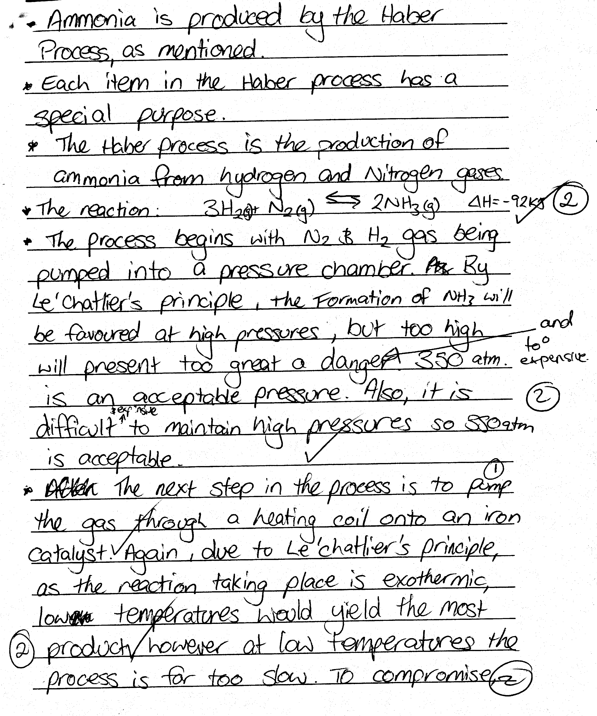
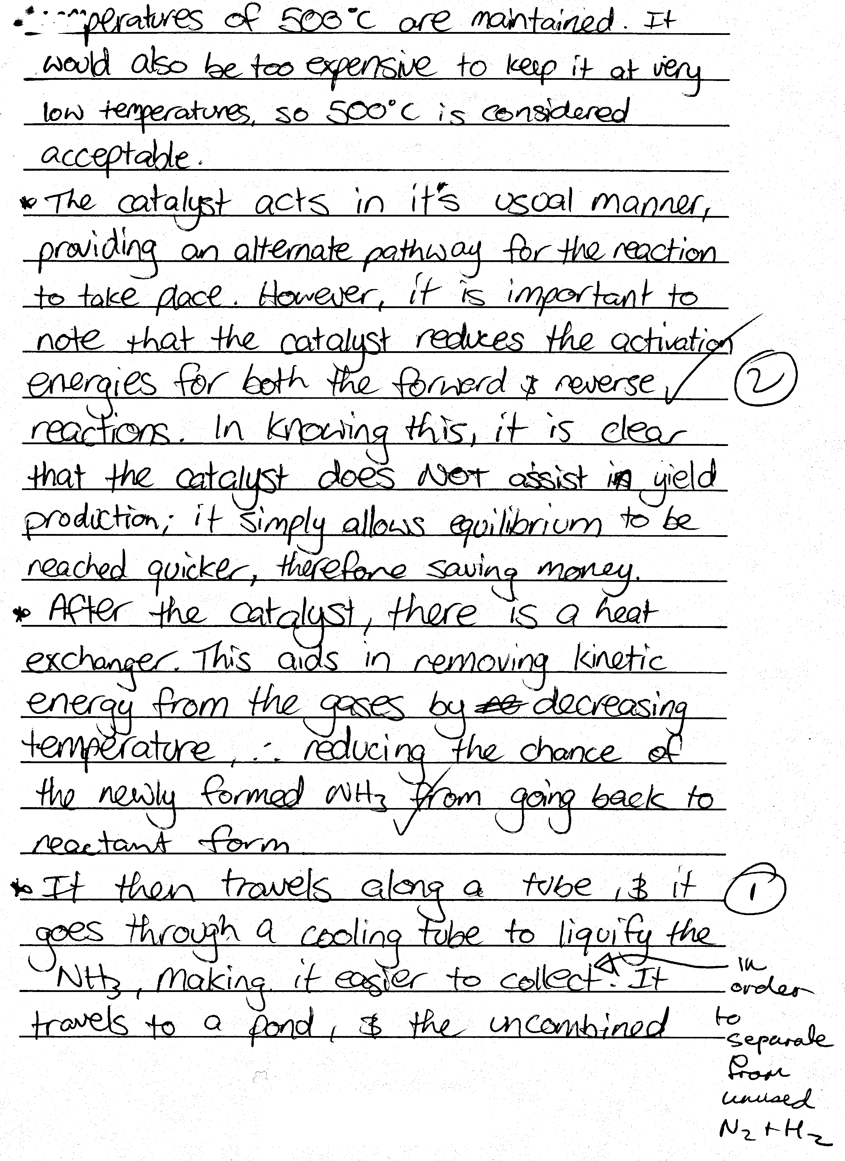
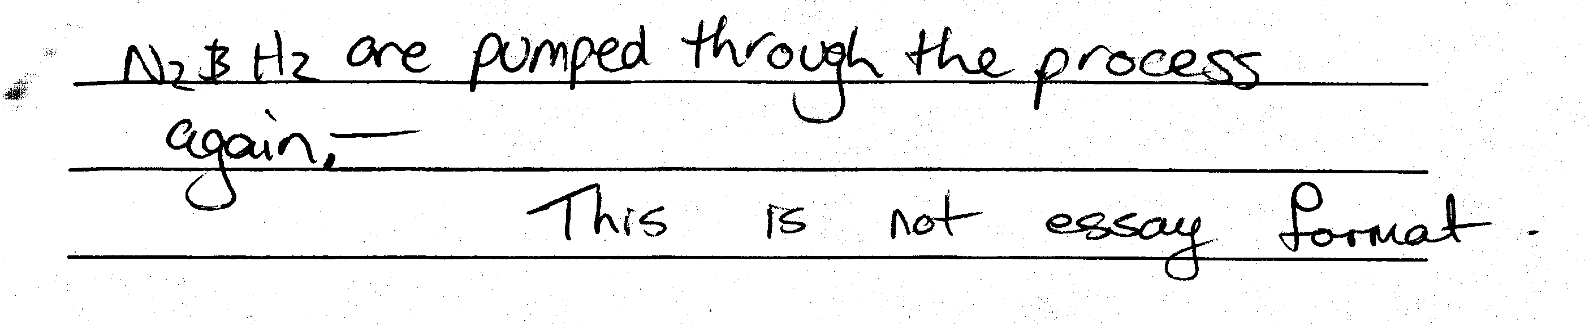

Question 2
(R. Marshall’s Essay)
